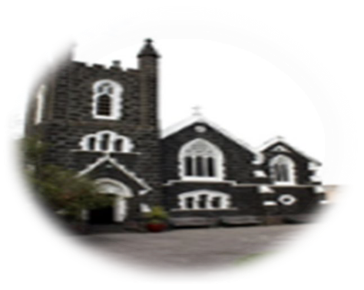

2ND Sunday of Easter/Divine Mercy Sunday, 7th April, 2024
First reading: Acts 4:32-35

The whole group of believers was united, heart and soul; no one claimed for his own use anything that he had, as everything they owned was held in common.
The apostles continued to testify to the resurrection of the Lord Jesus with great power, and they were all given great respect.
None of their members was ever in want, as all those who owned land or houses would sell them, and bring the money from them, to present it to the apostles; it was then distributed to any members who might be in need.

Responsorial Psalm: 117(118):2‐4,15‐18,22‐24
Give thanks to the Lord, for he is good; his love is everlasting.
Let the sons of Israel say: ‘His love has no end.’ Let the sons of Aaron say: ‘His love has no end.’ Let those who fear the Lord say: ‘His love has no end.’
Give thanks to the Lord, for he is good; his love is everlasting.
The Lord’s right hand has triumphed; his right hand raised me up.
I shall not die, I shall live and recount his deeds. I was punished, I was punished by the Lord, but not doomed to die.
Give thanks to the Lord, for he is good; his love is everlasting.
The stone which the builders rejected has become the corner stone. This is the work of the Lord, a marvel in our eyes. This day was made by the Lord; we rejoice and are glad.
Give thanks to the Lord, for he is good; his love is everlasting.
ST AUGUSTINE’S CATHOLIC CHURCH
BOURKE ST, MELBOURNE 3000
Parish Priest: Mons. Stuart Hall.
melbournebourkest@cam.org.au
TEL: +61 3 9412 8426

Second Reading: 1 John 5:1-6
Whoever believes that Jesus is the Christ
has been begotten by God; and whoever loves the Father that begot him loves the child whom he begets. We can be sure that we love God’s children if we love God himself and do what he has commanded us; this is what loving God is –keeping his commandments; and his commandments are not difficult, because anyone who has been begotten by God has already overcome the world; this is the victory over the world –our faith. Who can overcome the world? Only the man who believes that Jesus is the Son of God: Jesus Christ who came by water and blood, not with water only, but with water and blood; with the Spirit as another witness –since the Spirit is the truth.

Sequence Victimae Paschali Laudes
Christians, to the Paschal Victim, offer sacrifice and praise. The sheep are ransomed by the Lamb; and Christ, the undefiled, hath sinners to his Father reconciled. Death with life contended: combat strangely ended! Life’s own Champion, slain, yet lives to reign.
Tell us, Mary: say what thou didst see upon the way. The tomb the Living did enclose; I saw Christ’s glory as he rose!
The angels there attesting; shroud with grave-clothes resting. Christ, my hope, has risen: he goes before you into Galilee. That Christ is truly risen from the dead we know. Victorious king, thy mercy show!

Alleluia, alleluia!
You believe in me, Thomas, because you have seen me;
happy are those who have not seen me, but still believe!

Alleluia!
Gospel : John 20:19-31
In the evening of that same day, the first day of the week, the doors were closed in the room where the disciples were, for fear of the Jews. Jesus came and stood among them. He said to them, ‘Peace be with you’, and showed them his hands and his side. The disciples were filled with joy when they saw the Lord, and he said to them again, ‘Peace be with you.
‘As the Father sent me, so am I sending you.’ After saying this he breathed on them and said:
‘Receive the Holy Spirit. For those whose sins you retain, they are retained.’
Thomas, called the Twin, who was one of the Twelve, was not with them when Jesus came. When the disciples said, ‘We have seen the Lord’, he answered, ‘Unless I see the holes that the nails made in his hands and can put my finger into the holes they made, and unless I can put my hand into his side, I refuse to believe.’ Eight days later the disciples were in the house again and Thomas was with them. The doors were closed, but Jesus came in and stood among them. ‘Peace be with you’ he said. Then he spoke to Thomas, ‘Put your finger here; look, here are my hands. Give me your hand; put it into my side. Doubt no longer but believe.’ Thomas replied, ‘My Lord and my God!’ Jesus said to him: ‘You believe because you can see me. Happy are those who have not seen and yet believe.’ There were many other signs that Jesus worked and the disciples saw, but they are not recorded in this book. These are recorded so that you may believe that Jesus is the Christ, the Son of God, and that believing this you may have life through his name.

The Gospel of the Lord
ROSTER : 10.30am
Priest: Fr Jaycee Napoles; Readers: Alicia, Peter; MOC: Rosina; Altar servers: Hananta, Marfel, Melinda, Aryo
8pm Priest: Fr Jaycee Napoles; Reader: Sebastian; Altar Server: Trevor

PROJECT COMPASSION - please return your boxes / envelopes by placing them in the container located near the altar.

Weekday Mass: Tuesday, Wednesday & Friday at 1.05pm. Confessions available on Wednesday at 12.30pm.
Sacrament of Reconciliation Preparation for children begins 21st April. Please register by contacting the office. Forms available online / back of Church.

